**CASE STUDY**

**MODULE 4**

**DONE BY**

**RANJITH KUMAR**

**Tasks To Be Performed:**

1. Manage the scaling requirements of the company by:

a. Deploying multiple compute resources on the cloud as soon as the

load increases and the CPU utilization exceeds 80%

b. Removing the resources when the CPU utilization goes under 60%

2. Create a load balancer to distribute the load between compute resources.

3. Route the traffic to the company’s domain.

STEP 1 : Open EC2 from aws services

STEP 2 : Select launch instance and select AMI , Inastnace type , Keypair , Network settings and storage to create an instance

STEP 3 : Select Auto scaling group and create a autoscaling group

STEP 4 : Select the Autoscaling group and go to automatic scaling

STEP 5 : Select create dynamic policy to set cpu utilization 80% when load increases

Repeat same for the cpu utilization goes under 60%

STEP 6 : Select Load balancers > Create Load balancer > Classic Load balancer

STEP 7 : Select Internet-facing , VPC , Security groups , Listners and routing , cross-zone load balancing , connection draining to create a load balancer

STEP 8 : We can attach it to the instance or the auto scaling group as of our need

STEP 9 : Select Route 53 > Create hosted group

I did not purchase domain from the domain registrar as Iam free tier user

STEP 10 : Created public hosted group

STEP 11 : Select Create Record

STEP 12 : Records created to route the traffic

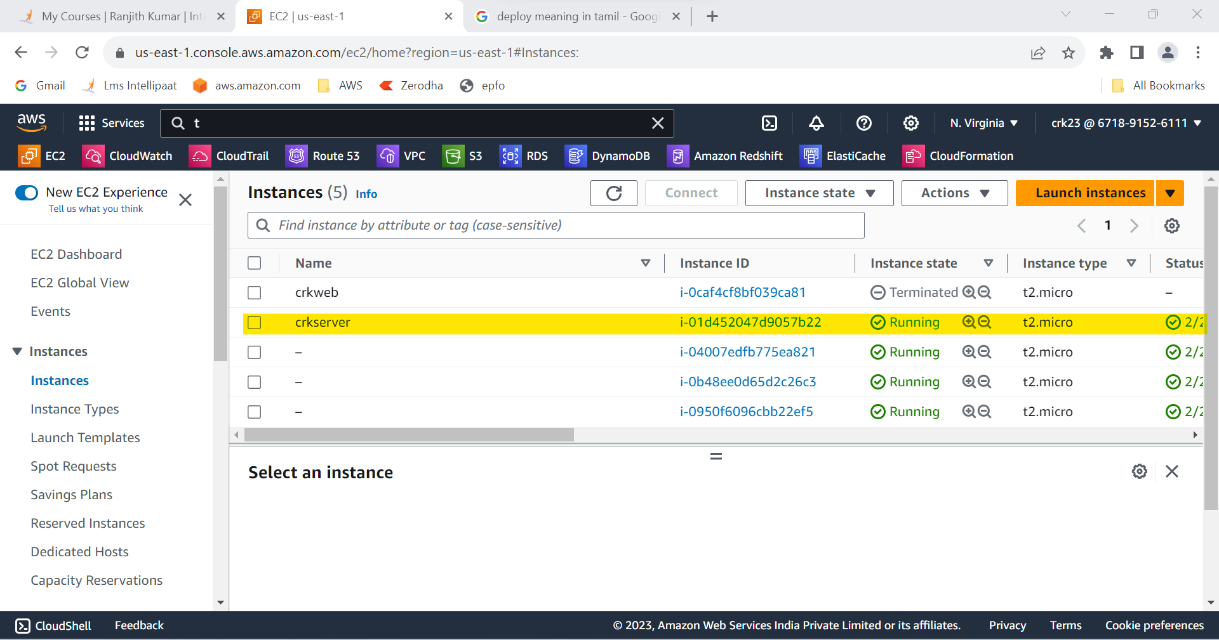

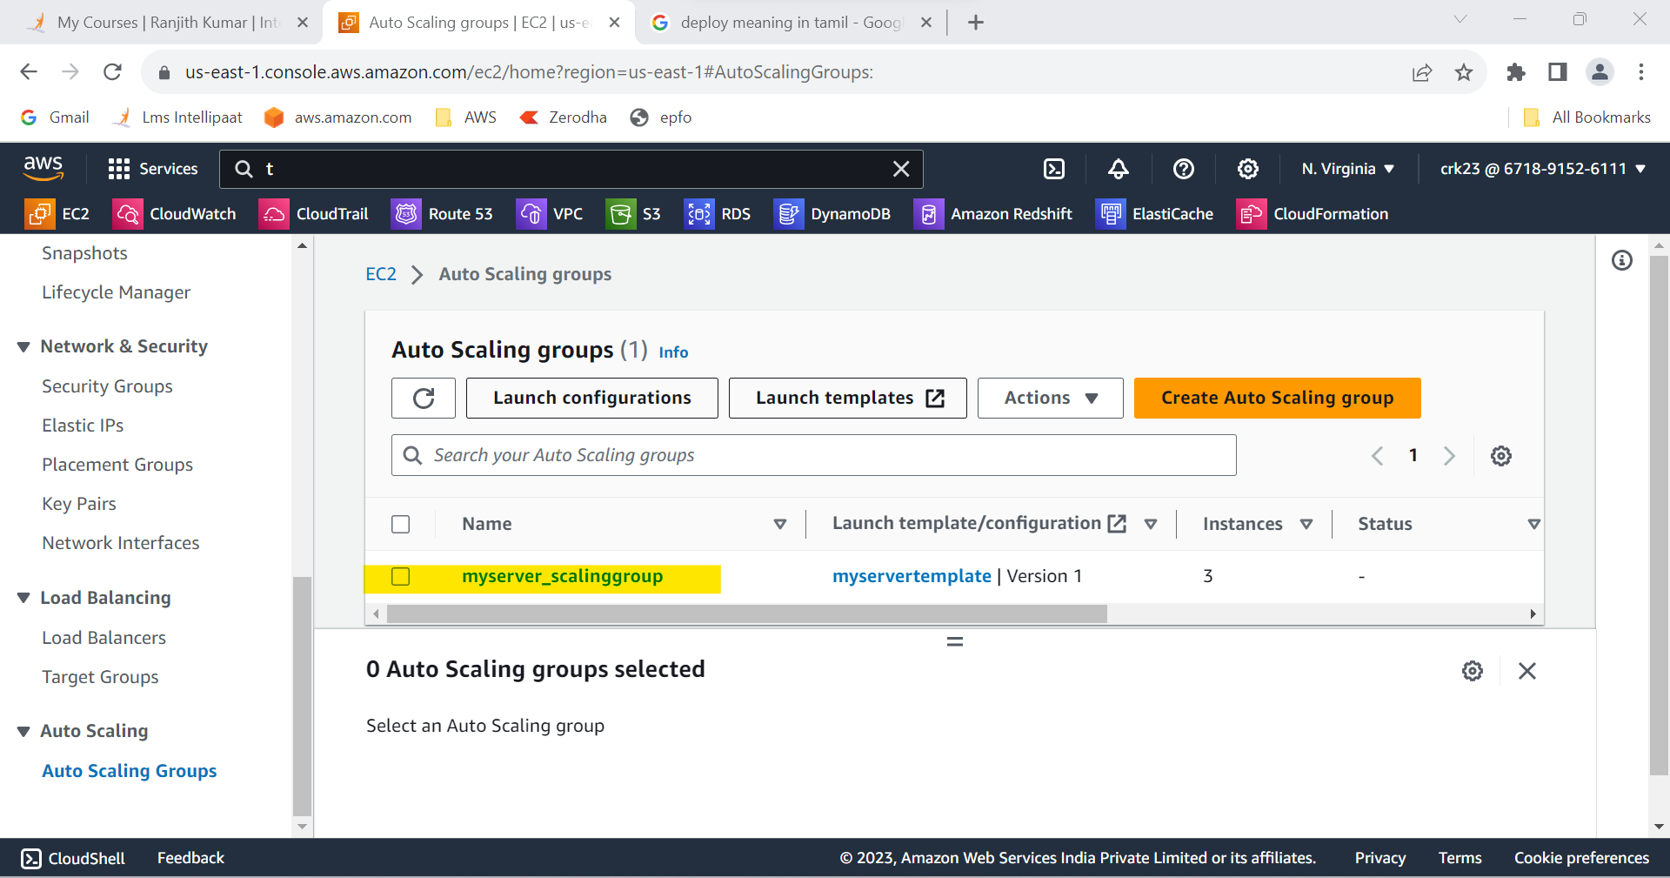

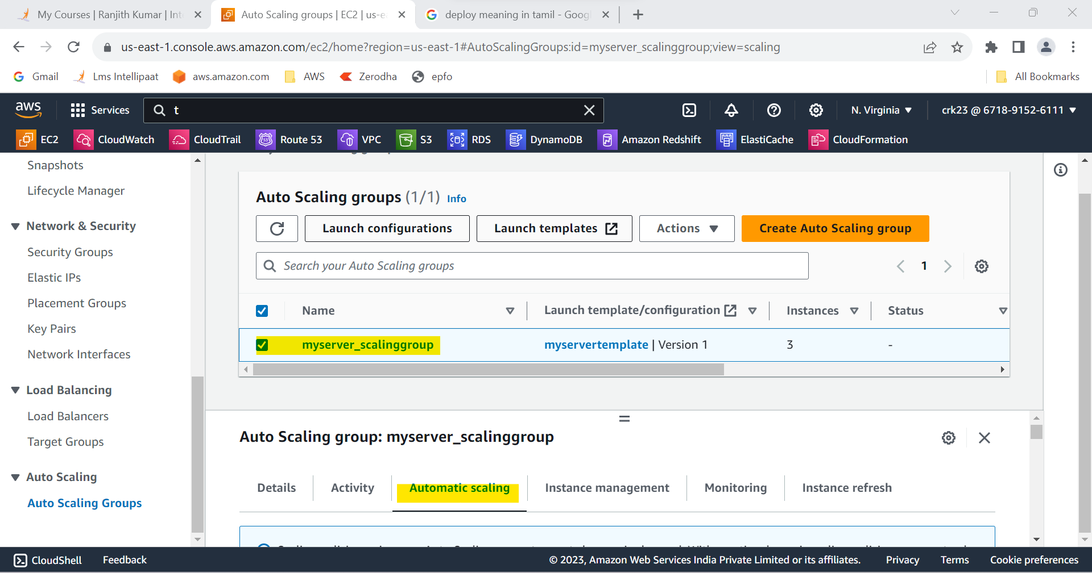

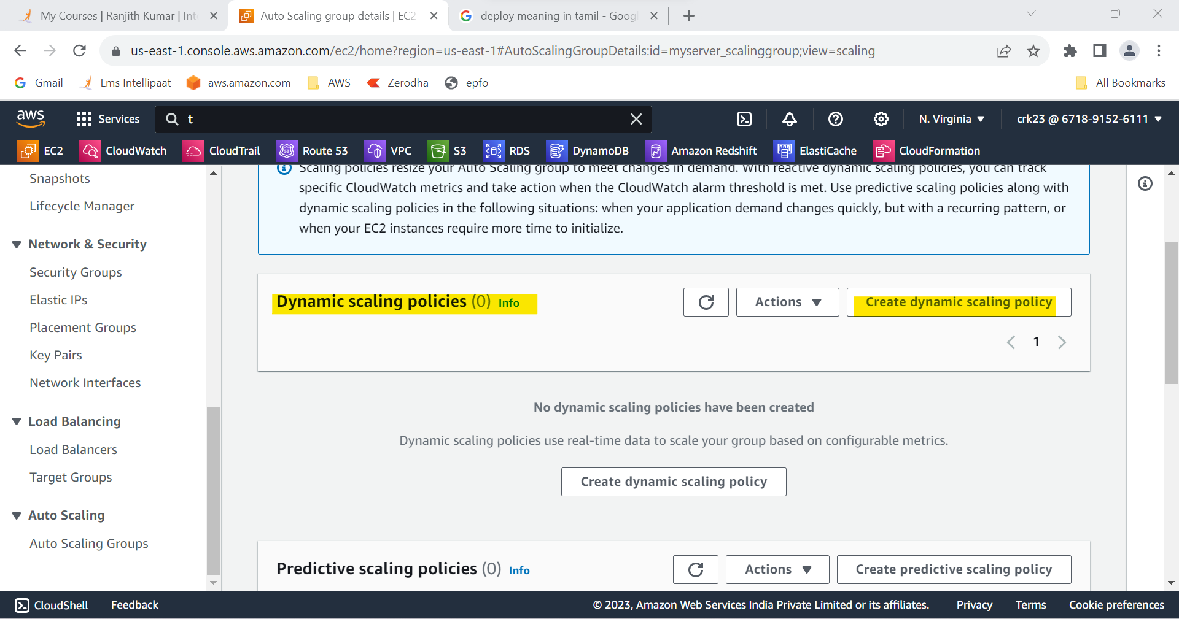

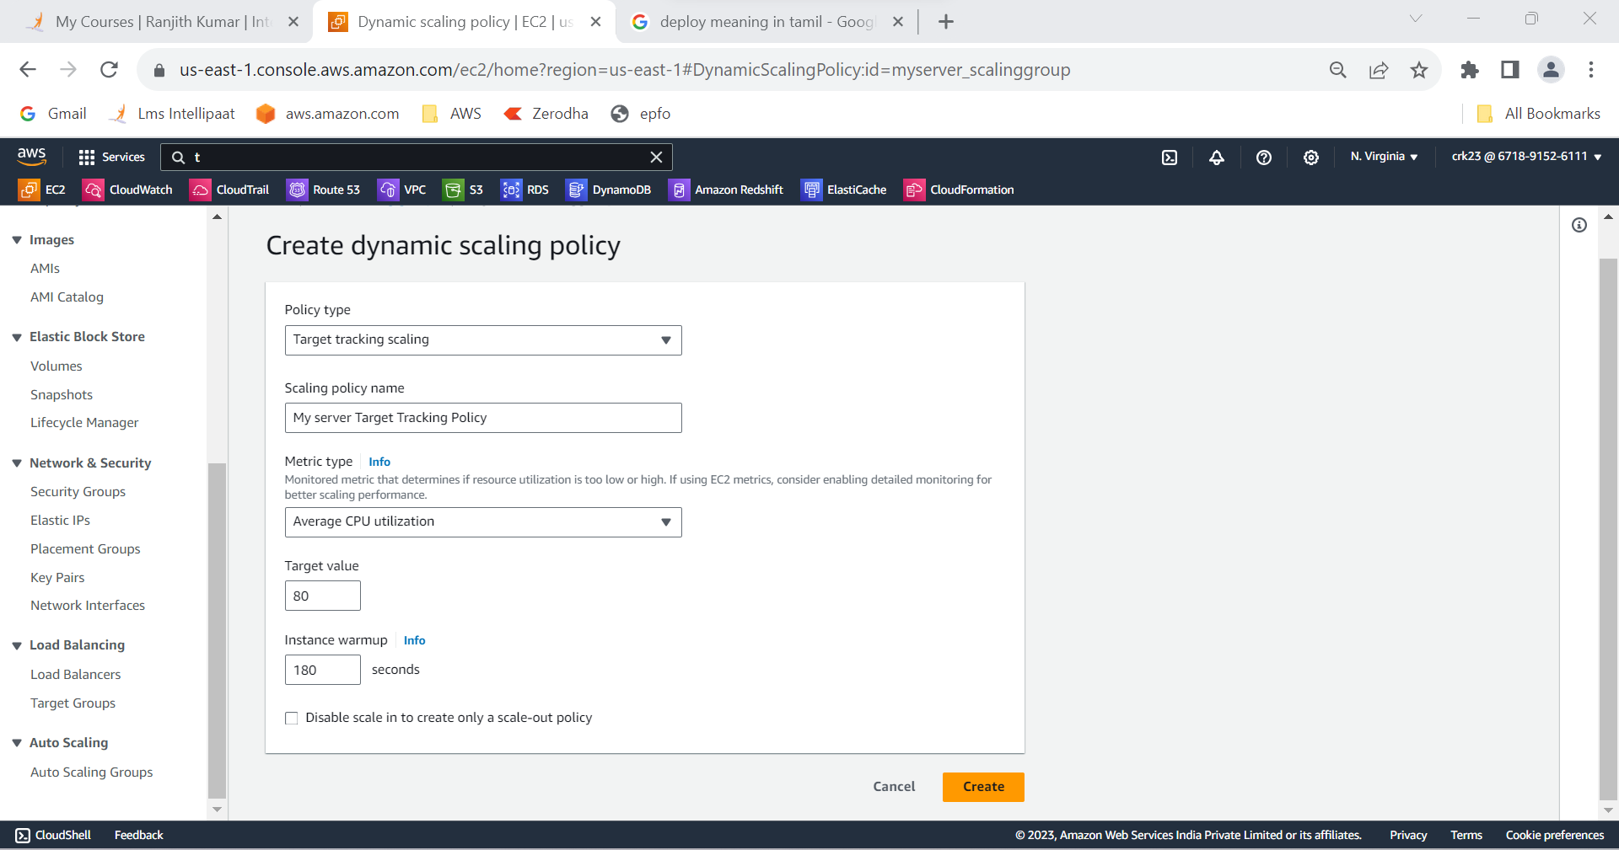

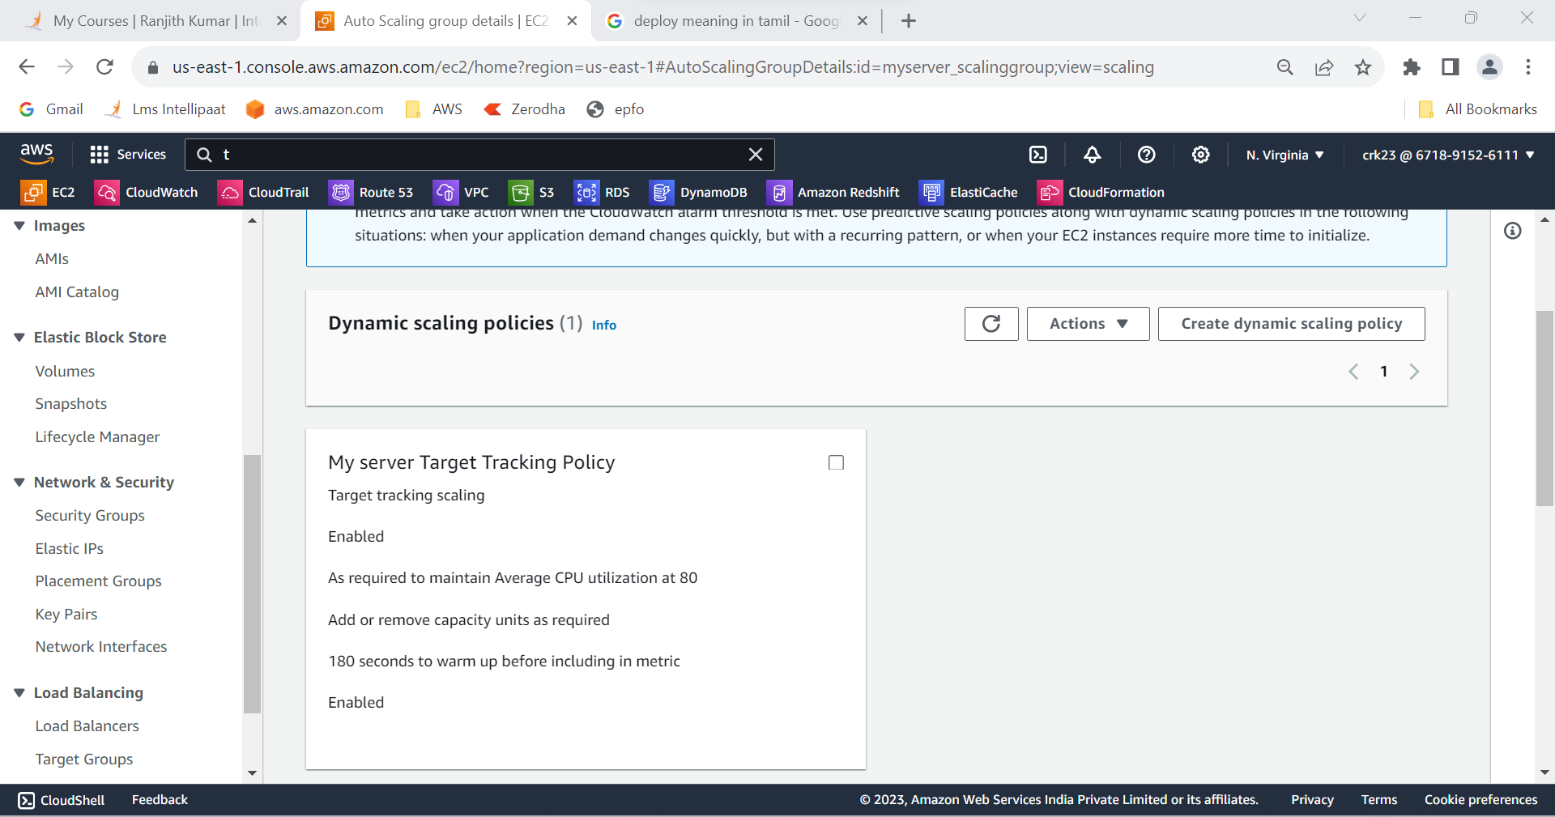

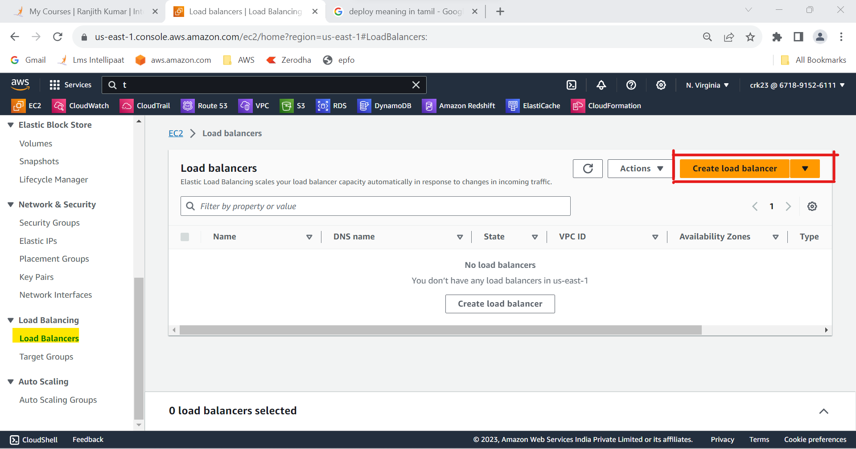

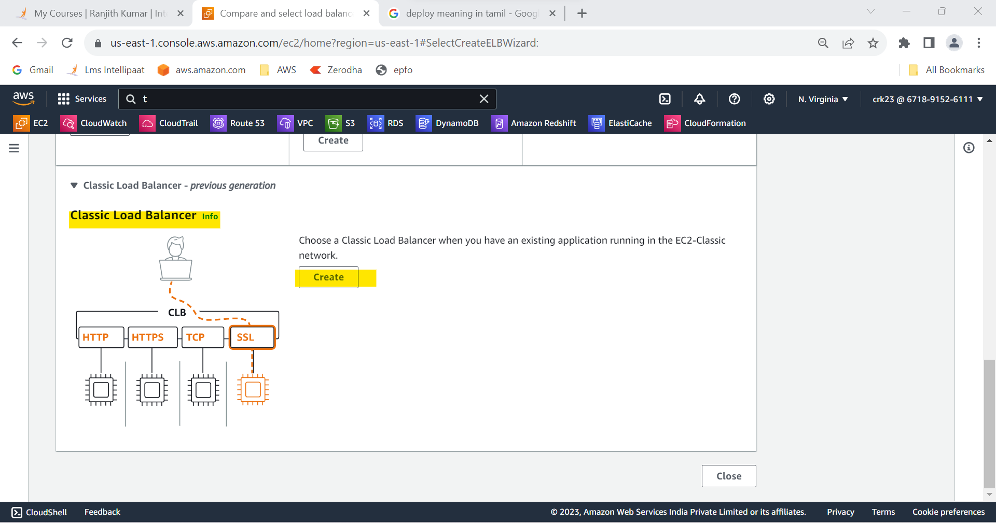

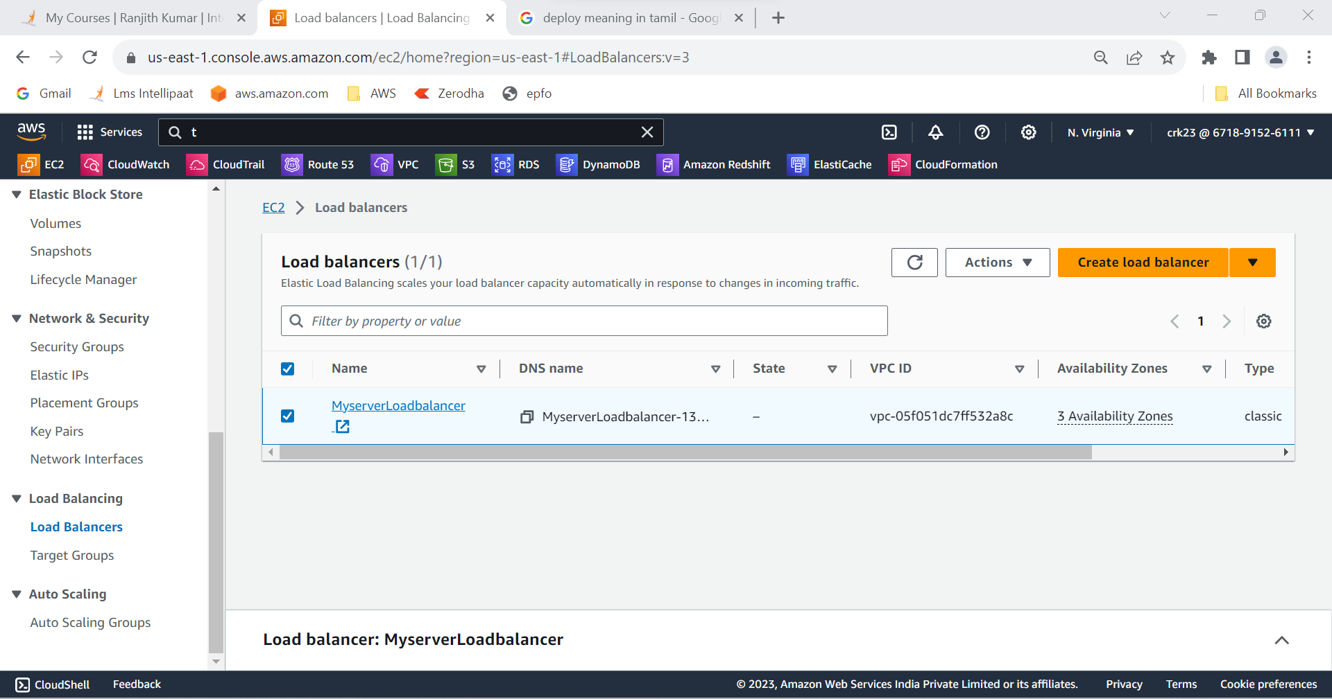

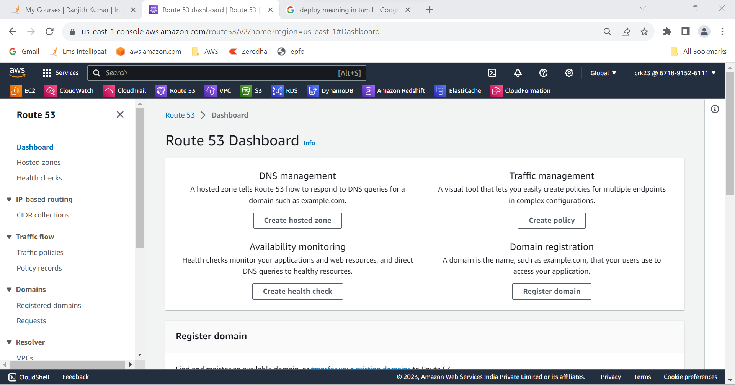

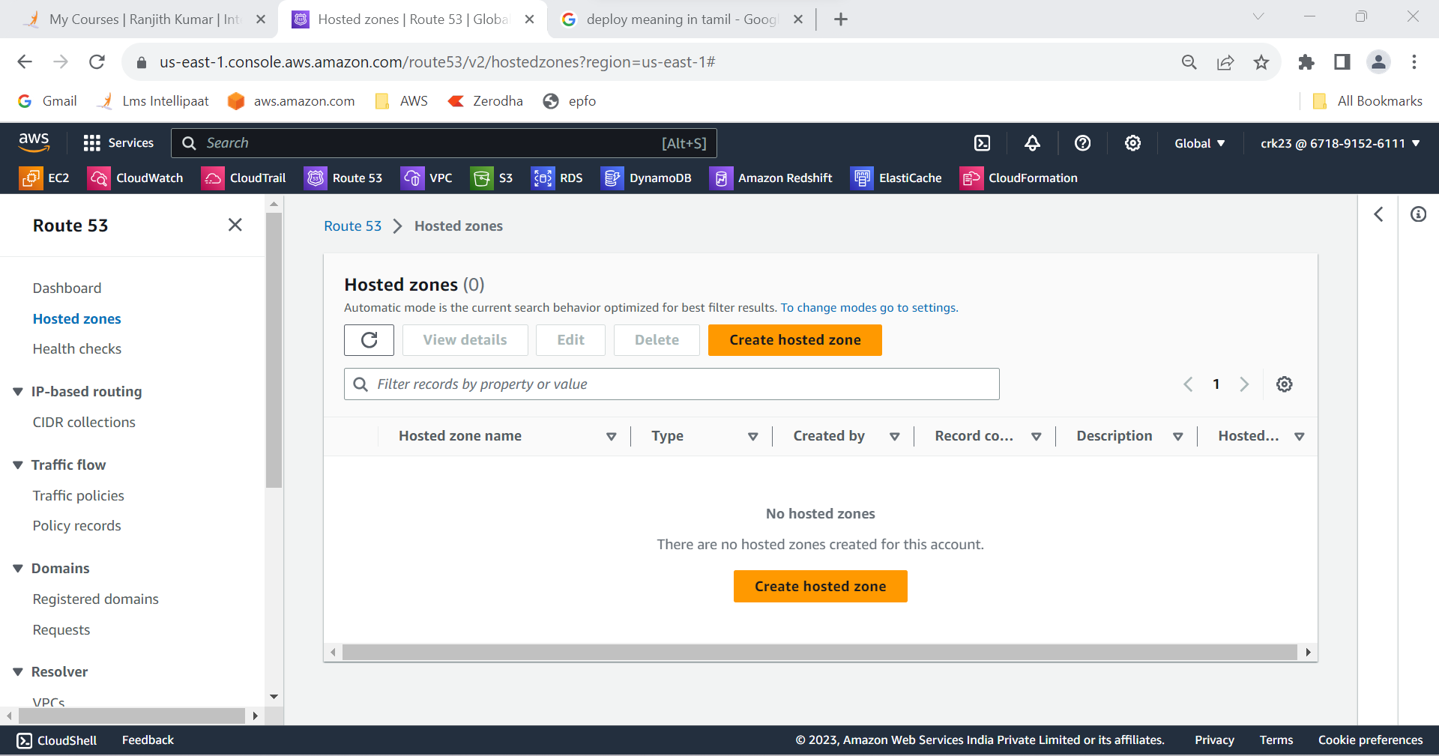

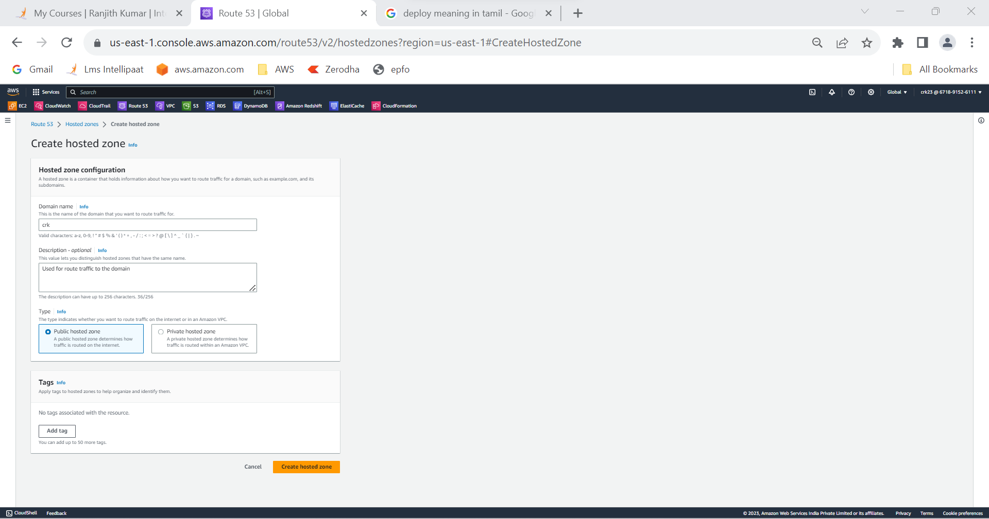

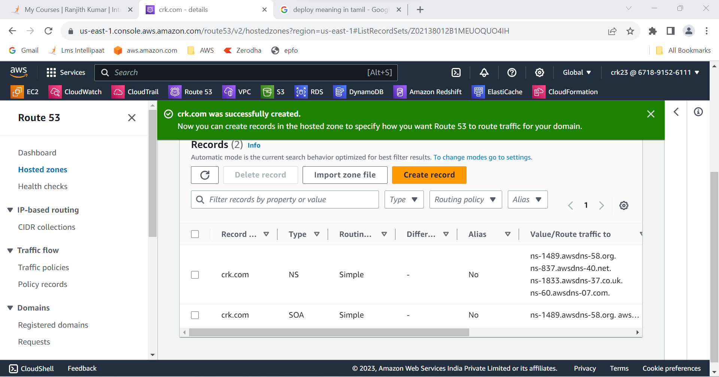

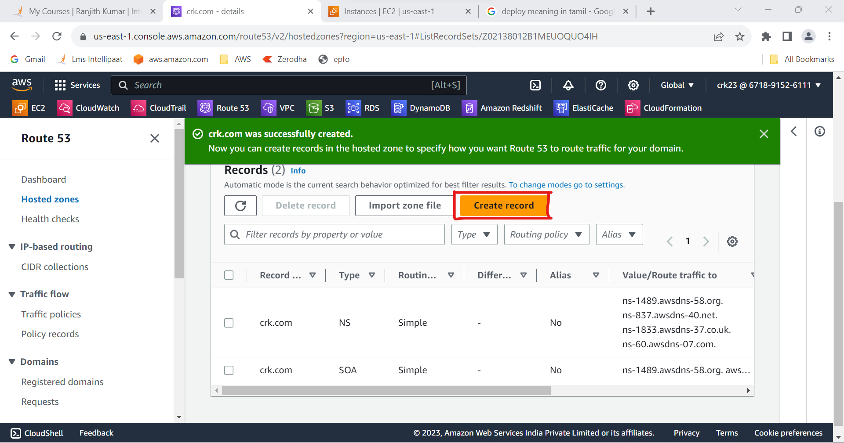

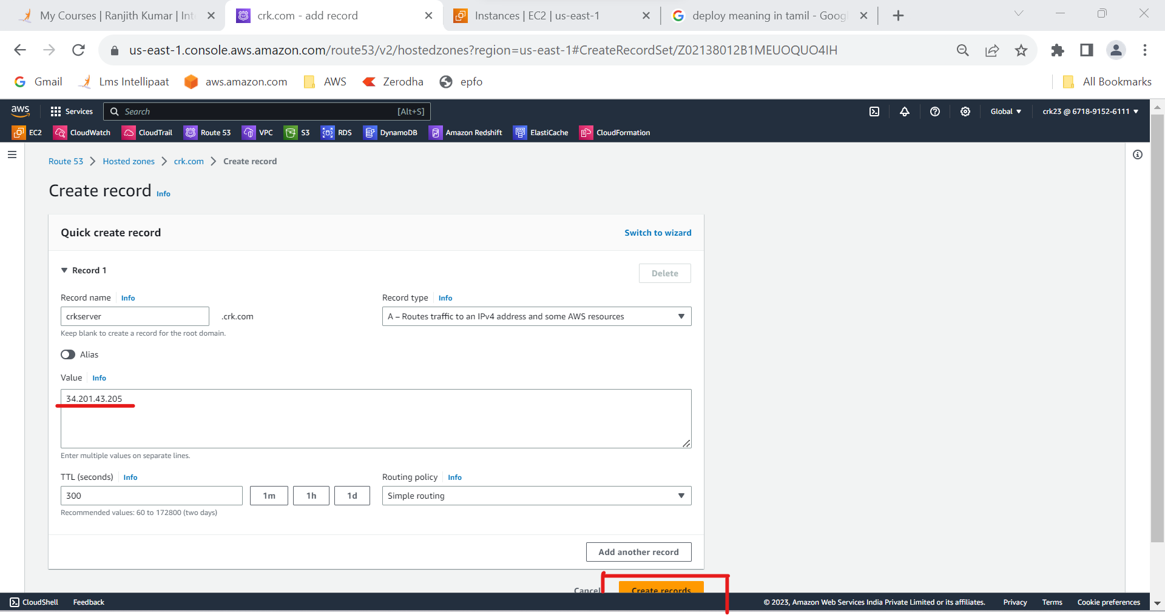

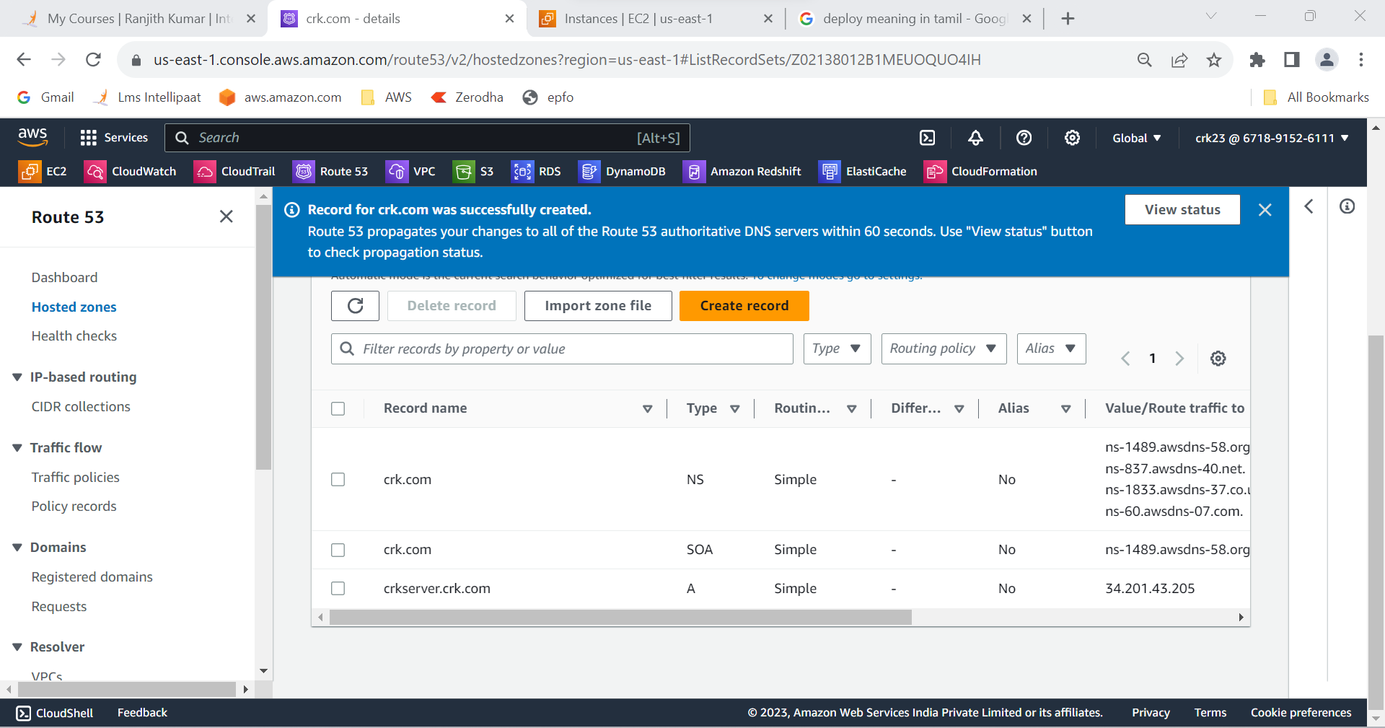

**OUTPUT :**

Managed scaling requirements as cpu utilization >80% and < 60% , Created load balancer and routed the traffic .